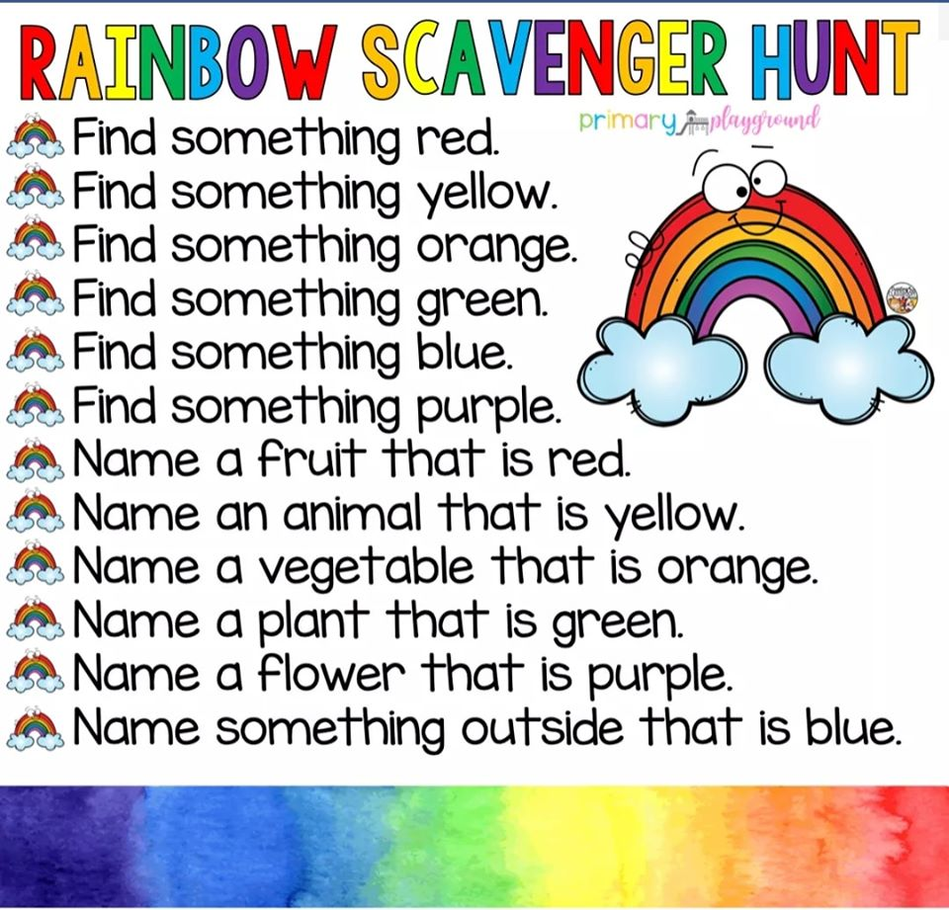
Remember that God showed Noah the rainbow after the flood. The rainbow is a sign of God’s promise to all living creatures including you. Our God keeps his promises—thank God for keeping his promises and for all the things you found on your scavenger hunt.

